NUCL 510 HMWK 8

1. HMWK #4 of Ch. 4

The change in velocity in CMS for a single collision is given by:

$$E_{n}^{c^{'}}=\frac{A}{A+1}E_{n}^{'}$$

For multiple collisions:

$$E_{n}^{c^{'}}\left(final\right)={\left(\frac{A}{A+1}\right)}^{n}E_{n}^{'}$$

$$E_{n}^{'}=2.0*{10}^{6} eV$$

$$E_{n}^{c^{'}}\left(final\right)=0.025 eV$$

$$\ln\left(\frac{E_{n}^{c^{'}}\left(final\right)}{E_{n}^{'}}\right)=n*\ln\left(\frac{A}{A+1}\right)$$

$$n=\frac{\ln\left(\frac{E_{n}^{c^{'}}\left(final\right)}{E_{n}^{'}}\right)}{\ln\left(\frac{A}{A+1}\right)}$$

$$n_{H}=26.25 collisions≈27 colisions$$

$$n_{C}=227.35 collisions≈228 collisions$$

1. HMWK #5 of Ch. 4

The use of lethargy when presenting a spectrum is a common practice in neutronics this stems from the fact that slowing down spectra not only is a negative process (going down in energy), but is logarithmic by definition. The use of $u=\ln{E_{0}/E}$ not only makes more slowing down correspond to higher numbers, but spreads out the slowing down process evenly over the domain of the independent variable than energy. It is makes it convenient that the average loss in lethargy becomes independent of energy. The use of lethargy also allows the plot of $φ(u)$ to have the same area be reprentative of the same number of reactions throughout all energy ranges. In a $φ(E)$ vs. $log⁡(E)$ plot, a visual area will represent a different amount of reactions throughout different energy ranges. This is the same reason for which the same spectrums are sometimes plotted as $Eφ(E)$ vs. $log⁡(E)$. (Ott, et al., 1989 pp. 175-179)

1. HMWK #9 of Ch. 4
   1. Deriving for hydrogenous, no absorption, energy dependent:
 $$Σ_{s}\left(E\right)φ\left(E\right)-\int_{E}^{∞}{Σ_{s}\left(E^{'}\right)φ(E^{'})\frac{dE^{'}}{E'}}=s_{o}χ\left(E\right)$$

 $$F\left(E\right)=Σ_{s}\left(E\right)φ\left(E\right)$$

 $$F\left(E\right)-\int_{E}^{∞}{F\left(E\right)\frac{dE^{'}}{E^{'}}}=s_{o}χ\left(E\right)$$

$$F\left(E\right)=s_{0}χ\left(E\right)+\frac{s_{0}}{E}\int_{E}^{∞}{χ\left(E^{'}\right)dE^{'}}$$

$$φ\left(E\right)=\frac{s_{0}}{Σ_{s}\left(E\right)}χ\left(E\right)+\frac{s_{0}}{EΣ_{s}\left(E\right)}\int_{E}^{∞}{χ\left(E^{'}\right)dE^{'}}$$

2. Analytical Solution Using $χ\left(E\right)=Ee^{-E}$
 $$φ\left(E\right)=\frac{s_{0}}{Σ_{s}\left(E\right)}χ\left(E\right)+\frac{s_{0}}{EΣ_{s}\left(E\right)}\int_{E}^{∞}{χ\left(E^{'}\right)dE^{'}}=\frac{s_{0}}{Σ_{s}\left(E\right)}Ee^{-E}+\frac{s_{0}}{EΣ_{s}\left(E\right)}\int_{E}^{∞}{E^{'}e^{-E^{'}}dE^{'}}=\frac{s_{0}}{Σ_{s}\left(E\right)}Ee^{-E}+\frac{s_{0}}{EΣ_{s}\left(E\right)}e^{-E}\left(E+1\right)=\frac{s_{0}}{Σ_{s}\left(E\right)}Ee^{-E}+\frac{s_{0}}{Σ_{s}\left(E\right)}e^{-E}+\frac{s_{0}}{EΣ_{s}\left(E\right)}e^{-E}=\frac{s_{0}}{Σ_{s}\left(E\right)}e^{-E}\left(E+1+\frac{1}{E}\right)$$

  3. Resulting Spectrum for $σ_{s}=20 b$

$$Σ_{s}\left(E\right)=σ_{s}N_{H}$$

$$φ\left(E\right)=\frac{s_{0}}{Σ_{s}\left(E\right)}e^{-E}\left(E+1+\frac{1}{E}\right)$$

$$N_{H}=\frac{ρ_{H}N_{A}}{M_{H}}=\frac{\left(8.99*{10}^{-5}\frac{g}{cm^{3}}\right)\left(6.022*{10}^{23}\frac{atoms}{mol}\right)}{1.01\frac{g}{mol}}$$

$$σ_{s}=20*{10}^{-14} cm^{2}$$

$$s_{0}=1$$

$$φ\left(E\right)=\frac{s_{0}}{σ_{s}N_{H}}e^{-E}\left(E+1+\frac{1}{E}\right)$$

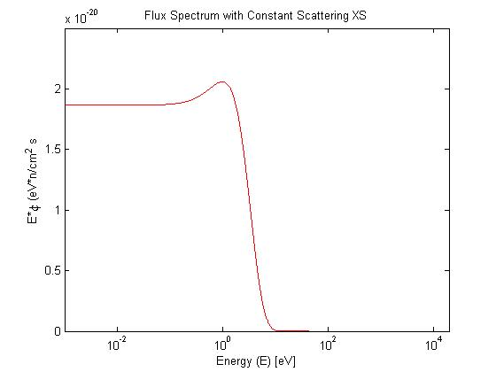

Figure Flux Spectrum with Constant Scattering XS

* 1. Several Points of Spectrum for $σ_{s}=20 b$…

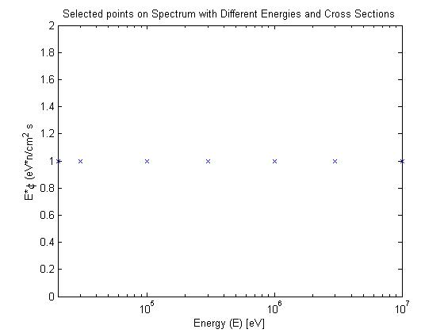

Figure Selected poitn on Spectrum with Different Energies and Cross Sections

* 1. Energy of Emitted Neutrons for 9b.

$$\overline{E}=\frac{\int_{0}^{E}{E'φ\left(E^{'}\right)dE^{'}}}{\int_{0}^{E}{φ\left(E^{'}\right)dE^{'}}}=\frac{\int_{0}^{E}{\frac{s_{0}}{σ_{s}N_{H}}E^{'}e^{-E'}\left(E'+1+\frac{1}{E'}\right)dE^{'}}}{\int_{0}^{E}{\frac{s_{0}}{σ_{s}N_{H}}e^{-E'}\left(E'+1+\frac{1}{E'}\right)dE^{'}}}=\frac{s_{0}\left(E^{2}+3E+4\right)}{N_{H}*σ_{s}*\exp\left(E\right)*\frac{2*\frac{s_{0}}{\exp\left(E\right)}+\frac{Es_{0}}{\exp\left(E\right)}}{N_{H}σ_{s}}-s_{0}*\frac{Ei\left(-E\right)}{N_{H}*σ_{s}}}$$

1. HMWK #11 of Ch. 4

$$n_{m}\left(E\right)=\frac{2}{\sqrt{π}}\frac{\sqrt{E}}{{\left(kT\right)}^{\frac{3}{2}}}\exp\left(-\frac{E}{kT}\right)$$

The Maxwellian distribution is given in the figure below for two different temperatures. The black line indicates the cutoff for thermal energies ($E=0.025 eV$). As can be seen by the filled areas, the percentage of the neutrons that fall below thermal energies for 298.15 K is higher than for that of 473.15 K. This means that a higher incident total flux will be needed for higher temperatures to reach the same count rate, which is reflected in the analytical solutions below.

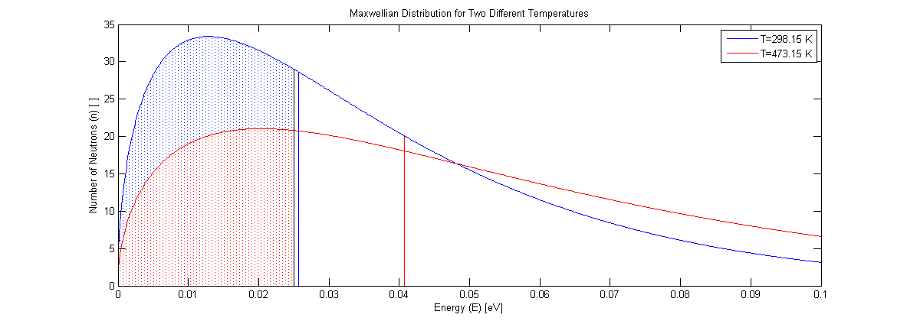

Figure Maxwellian Distributions for Different Energies

* 1. Magnitude of Incident Total Neutron Flux

$$T=298.15 K$$

Efficiency of detection for **thermal** incident neutrons is given as:

* 1. If Maxwellian at 200oC, neutron flux level for same count rate

$$T=473.15 K$$

Assuming still only **thermal** neutrons are detected, so using equation from above:

* 1. Relative count rate between neutrons at 25 and 200oC

1. HMWK #1 of Ch. 5
   1. Derive Energy Dependence from Breit-Wigner formula for lowest s-wave resonance

The single-level Breit-Wigner formula is:

$$σ_{j}\left(E\right)=4πλ^{2}g_{R}\frac{Γ_{n}Γ_{j}}{Γ^{2}}\frac{{\left(\frac{Γ}{2}\right)}^{2}}{{\left(E-E_{R}\right)}^{2}+{\left(\frac{Γ}{2}\right)}^{2}}$$

$$σ_{j}\left(E\right)=4πλ^{2}g_{R}\frac{Γ_{n}Γ_{j}}{Γ^{2}}\frac{{\left(\frac{Γ}{2}\right)}^{2}}{{\left(E-E_{R}\right)}^{2}+{\left(\frac{Γ}{2}\right)}^{2}}$$

For s-wave resonances:

$$Γ_{n}=Γ_{N}^{0}\sqrt{E}$$

$$σ_{j}\left(E\right)=4πλ^{2}g_{R}\frac{Γ_{N}^{0}\sqrt{E}Γ_{j}}{Γ^{2}}\frac{{\left(\frac{Γ}{2}\right)}^{2}}{{\left(E-E_{R}\right)}^{2}+{\left(\frac{Γ}{2}\right)}^{2}}$$

$$λ=\frac{h}{2πmv}$$

$$λ^{2}=\frac{h^{2}}{4π^{2}m^{2}v^{2}}=\frac{h^{2}}{2π^{2}mE}$$

$$σ_{j}\left(E\right)=\frac{2h^{2}}{πmE}g_{R}\frac{Γ_{N}^{0}\sqrt{E}Γ_{j}}{Γ^{2}}\frac{{\left(\frac{Γ}{2}\right)}^{2}}{{\left(E-E_{R}\right)}^{2}+{\left(\frac{Γ}{2}\right)}^{2}}$$

For s-wave resonances:

When

* 1. Express result in terms of neutron velocity

$$σ_{j}\left(E\right)=\frac{1}{\sqrt{E}}\frac{2h^{2}}{πm}\frac{Γ_{N}^{0}Γ_{j}}{Γ^{2}}\frac{{\left(\frac{Γ}{2}\right)}^{2}}{{\left(E_{R}\right)}^{2}+{\left(\frac{Γ}{2}\right)}^{2}}=\frac{\sqrt{2}}{v\sqrt{m}}\frac{2h^{2}}{πm}\frac{Γ_{N}^{0}Γ_{j}}{Γ^{2}}\frac{{\left(\frac{Γ}{2}\right)}^{2}}{{\left(E_{R}\right)}^{2}+{\left(\frac{Γ}{2}\right)}^{2}}=\frac{1}{v}\frac{2^{\frac{3}{2}}h^{2}}{πm^{\frac{3}{2}}}\frac{Γ_{N}^{0}Γ_{j}}{Γ^{2}}\frac{{\left(\frac{Γ}{2}\right)}^{2}}{{\left(E_{R}\right)}^{2}+{\left(\frac{Γ}{2}\right)}^{2}}$$

This shows the $1/v$ dependence of resonance width for capture and fission cross sections.

* 1. Find Energy dependence of $σ_{s}(E)$ for small $E$.

$$σ_{s}\left(E\right)=4πλ^{2}g_{R}\frac{{\left(\frac{Γ_{n}}{2}\right)}^{2}}{{\left(E-E_{R}\right)}^{2}+{\left(\frac{Γ}{2}\right)}^{2}}+4πR_{N}^{2}+4πλg_{R}\frac{Γ_{n}\left(E-E_{R}\right)R_{N}}{{\left(E-E_{R}\right)}^{2}+{\left(\frac{Γ}{2}\right)}^{2}}$$

$$λ=\frac{h}{2πmv}=\frac{h}{2π\sqrt{2mE}}$$

$$λ^{2}=\frac{h^{2}}{4π^{2}m^{2}v^{2}}=\frac{h^{2}}{2π^{2}mE}$$

$$g_{R}=1$$

$$σ_{s}\left(E\right)=2\frac{h^{2}}{πmE}\frac{{\left(\frac{Γ_{N}^{0}\sqrt{E}}{2}\right)}^{2}}{{\left(E-E_{R}\right)}^{2}+{\left(\frac{Γ}{2}\right)}^{2}}+4πR_{N}^{2}+2\frac{h}{\sqrt{2mE}}\frac{Γ_{N}^{0}\sqrt{E}\left(E-E_{R}\right)R_{N}}{{\left(E-E_{R}\right)}^{2}+{\left(\frac{Γ}{2}\right)}^{2}}$$

As $E→0$:

$$σ_{s}\left(E\right)=2\frac{h^{2}}{πmE}\frac{{\left(\frac{Γ_{N}^{0}\sqrt{E}}{2}\right)}^{2}}{{\left(E-E_{R}\right)}^{2}+{\left(\frac{Γ}{2}\right)}^{2}}+4πR_{N}^{2}+2\frac{h}{\sqrt{2mE}}\frac{Γ_{N}^{0}\sqrt{E}\left({E-E}_{R}\right)R_{N}}{{\left(E-E_{R}\right)}^{2}+{\left(\frac{Γ}{2}\right)}^{2}}$$

$$\lim_{E→0}\left(\frac{2h^{2}{\left(\frac{Γ_{N}^{0}\sqrt{E}}{2}\right)}^{2}}{πmE{\left(E-E_{R}\right)}^{2}+πmE{\left(\frac{Γ}{2}\right)}^{2}}\right)=0$$

$$\lim_{E→0}\left(\frac{2hΓ_{N}^{0}\sqrt{E}\left({E-E}_{R}\right)R_{N}}{{\sqrt{2mE}\left(E-E_{R}\right)}^{2}+{\sqrt{2mE}\left(\frac{Γ}{2}\right)}^{2}}\right)=\lim_{E→0}\left(\frac{2hΓ_{N}^{0}\sqrt{E}R_{N}}{\frac{m\left(E_{R}-5E\right)\left(E_{R}-E\right)}{\sqrt{2mE}}+{\frac{\sqrt{m}}{\sqrt{2E}}\left(\frac{Γ}{2}\right)}^{2}}\right)=0$$

$$∴ σ_{s}\left(E\right)=4πR_{N}^{2}$$

This shows that there is no energy dependence for the scattering cross section at thermal energies.

1. HMWK #5 of Ch. 5
   1. J function for natural line shape

Or:

* 1. Ratio of reaction rates for self-shielding and no self-shielding
 $$I_{238}=\int_{Eth}^{Eu}{\frac{σ_{b}}{σ_{b}+σ_{t}^{res}\left(E\right)}σ_{a}\left(E\right)\frac{dE}{E}}$$

 $$I_{238,∞}=\int_{Eth}^{Eu}{σ_{a}\left(E\right)\frac{dE}{E}}$$

$$ratio=\frac{\int_{Eth}^{Eu}{\frac{σ_{b}}{σ_{b}+σ_{t}^{res}\left(E\right)}σ_{a}\left(E\right)\frac{dE}{E}}}{\int_{Eth}^{Eu}{σ_{a}\left(E\right)\frac{dE}{E}}}$$

2. Ratio of reaction rates with different ratio of U-238

$$I_{238}=\int_{Eth}^{Eu}{\frac{Σ_{p}}{Σ_{p}+Σ_{ti}^{res}\left(E\right)}σ_{a}\left(E\right)\frac{dE}{E}}$$

$$where N_{B,p}=0.111*N_{B0}$$

$$I_{238}=\int_{Eth}^{Eu}{\frac{0.111*σ_{b}}{0.111*σ_{b}+σ_{t}^{res}\left(E\right)}σ_{a}\left(E\right)\frac{dE}{E}}$$

$$I_{238,∞}=\int_{Eth}^{Eu}{σ_{a}\left(E\right)\frac{dE}{E}}$$

$$ratio=\frac{\int_{Eth}^{Eu}{\frac{0.111*σ_{b}}{0.111*σ_{b}+σ_{t}^{res}\left(E\right)}σ_{a}\left(E\right)\frac{dE}{E}}}{\int_{Eth}^{Eu}{σ_{a}\left(E\right)\frac{dE}{E}}}$$

1. HMWK #6 of Ch. 5 (accidentally did this problem when the above problem was assigned, left it in here)
 $$I_{eff}=3.8 {\left(\frac{Σ_{s}}{N_{U}}\right)}^{0.42}$$

 $$σ_{s}^{U}=8.3 b$$

 1. Natural-uranium fueled graphite reactor where number of carbon atoms to uranium is 500

$$\frac{N_{C}}{N_{U}}=500$$

$$σ_{s}^{C}=4.7 b$$

$$p=\exp\left(-\frac{1}{ξΣ_{p}}\left(N_{U}I_{U}+N_{C}I_{C}\right)\right)$$

$$I_{U}=3.8 {\left(\frac{Σ_{s}}{N_{U}}\right)}^{0.42}=3.8{\left(\frac{σ_{s}^{U}N_{U}}{N_{U}}\right)}^{0.42}=3.8{\left(σ_{s}^{U}\right)}^{0.42}$$

$$I_{C}=3.8 {\left(\frac{Σ_{s}}{N_{U}}\right)}^{0.42}=3.8{\left(\frac{σ_{s}^{C}N_{C}}{N_{U}}\right)}^{0.42}=3.8{\left(500\right)}^{0.42}{\left(σ_{s}^{C}\right)}^{0.42}$$

Assuming $Σ_{p}=N_{i}σ_{s}^{i}$:

$$\overline{ξ}Σ_{p}=\overline{ξΣ_{p}}=\sum{\frac{ξσ_{s}^{i}N_{i}}{N_{i}}}=\frac{ξ_{U}σ_{s}^{U}N_{U}+ξ_{C}σ_{s}^{C}N_{C}}{N_{U}+N_{C}}=\frac{ξ_{U}σ_{s}^{U}+5ξ_{H_{2}O}σ_{s}^{H_{2}O}}{1+500}$$

$$p=\exp\left(-\frac{1+500}{ξ_{U}σ_{s}^{U}+500ξ_{C}σ_{s}^{C}}\left(N_{U}3.8{\left(σ_{s}^{U}\right)}^{0.42}+N_{C}3.8{\left(500\right)}^{0.42}{\left(σ_{s}^{C}\right)}^{0.42}\right)\right)$$

Dividing through by $N_{u}$:

$$p=\exp\left(-\frac{1+500}{ξ_{U}σ_{s}^{U}+500ξ_{C}σ_{s}^{C}}\left(3.8{\left(σ_{s}^{U}\right)}^{0.42}+500*3.8{\left(500\right)}^{0.42}{\left(σ_{s}^{C}\right)}^{0.42}\right)\right)$$

Using Values from table 4-II:

* 1. Natural-uranium fueled light water reactor where number of water atoms to uranium is 5

$$\frac{N_{H_{2}O}}{N_{U}}=5$$

$$σ_{H_{2}O}=44.8 b$$

$$p=\exp\left(-\frac{1}{ξΣ_{p}}\left(N_{U}I_{U}+N_{H_{2}O}I_{H_{2}O}\right)\right)$$

$$I_{U}=3.8 {\left(\frac{Σ_{s}}{N_{U}}\right)}^{0.42}=3.8{\left(\frac{σ_{s}^{U}N_{U}}{N_{U}}\right)}^{0.42}=3.8{\left(σ_{s}^{U}\right)}^{0.42}$$

$$I_{H_{2}O}=3.8 {\left(\frac{Σ_{s}}{N_{U}}\right)}^{0.42}=3.8{\left(\frac{σ_{s}^{H_{2}O}N_{H_{2}O}}{N_{U}}\right)}^{0.42}=3.8{\left(5\right)}^{0.42}{\left(σ_{s}^{H_{2}O}\right)}^{0.42}$$

Assuming $Σ_{p}=N_{i}σ_{s}^{i}$:

$$\overline{ξ}Σ_{p}=\overline{ξΣ_{p}}=\sum{\frac{ξσ_{s}^{i}N_{i}}{N_{i}}}=\frac{ξ_{U}σ_{s}^{U}N_{U}+ξ_{H_{2}O}σ_{s}^{H_{2}O}N_{H_{2}O}}{N_{U}+N_{H_{2}O}}=\frac{ξ_{U}σ_{s}^{U}+5ξ_{H_{2}O}σ_{s}^{H_{2}O}}{1+5}$$

$$p=\exp\left(-\frac{1+5}{ξ_{U}σ_{s}^{U}+5ξ_{H_{2}O}σ_{s}^{H_{2}O}}\left(N_{U}3.8{\left(σ_{s}^{U}\right)}^{0.42}+N_{H_{2}O}3.8{\left(5\right)}^{0.42}{\left(σ_{s}^{H_{2}O}\right)}^{0.42}\right)\right)$$

Dividing through by $N_{u}$:

$$p=\exp\left(-\frac{1+5}{ξ_{U}σ_{s}^{U}+5ξ_{H_{2}O}σ_{s}^{H_{2}O}}\left(3.8{\left(σ_{s}^{U}\right)}^{0.42}+5*3.8{\left(5\right)}^{0.42}{\left(σ_{s}^{H_{2}O}\right)}^{0.42}\right)\right)$$

Using Values from table 4-II:

$$ξ_{H_{2}O}=1+\frac{{\left(A-1\right)}^{2}}{2A}\ln\left(\frac{A-1}{A+1}\right)=1+\frac{{\left(18-1\right)}^{2}}{2*18}\ln\left(\frac{18-1}{18+1}\right)=0.1071$$

$$p=\exp\left(-\frac{1+5}{0.0084*σ_{s}^{U}+5*0.1071*σ_{s}^{H_{2}O}}\left(3.8{\left(σ_{s}^{U}\right)}^{0.42}+5*3.8{\left(5\right)}^{0.42}{\left(σ_{s}^{H_{2}O}\right)}^{0.42}\right)\right)$$

$$p=3.6037*{10}^{-21}$$